

**Human Computer Interaction**

**Project Report**

**3rd Semester**

**Section “B”**

**Submitted to:**

Sir Junaid Ali Khan

**Submitted by:**

SHAHZAD BABAR 22-SE-087

**Department of SOFTWARE ENGINEERING**

**HITEC University, Taxila**

**E-CLOTHING MART**

# **Abstract:**

The main aim of “Online fashion Shopping” website is to cut the convenience of the user while shopping the products in shopping complexes. This online fashion shopping helps the user to shop fashion clothing„s for men‟s, women‟s and kid‟s through online so that the user not need to move for shopping. The site is attractive and user friendly so that any new user to the site, easy to purchase the product.

# **Introduction:**

Online shopping is a form of [electronic commerce](https://en.wikipedia.org/wiki/Electronic_commerce) which allows consumers to directly buy [goods](https://en.wikipedia.org/wiki/Good_(economics)) or [services](https://en.wikipedia.org/wiki/Service_(economics)) from a seller over the [Internet](https://en.wikipedia.org/wiki/Internet) using a [web browser](https://en.wikipedia.org/wiki/Web_browser) or a [mobile app](https://en.wikipedia.org/wiki/Mobile_app). Consumers find a product of interest by visiting the [website](https://en.wikipedia.org/wiki/Website) of the retailer directly or by searching among alternative vendors using a [shopping search engine](https://en.wikipedia.org/wiki/Shopping_search_engine), which displays the same product's availability and pricing at different e-retailers.

# **System Functionalities:**

1. Product Catalogue
2. Product Categories
3. Cart
4. Transaction Handling

# **Justification of UI Principles:**

## Visibility:

Our user interface is really visible. He or she can view various button icons, color combinations, and menu alternatives without any reluctance on the part of the user. Additionally, the interface's typeface and alignment are considerably more prominent.

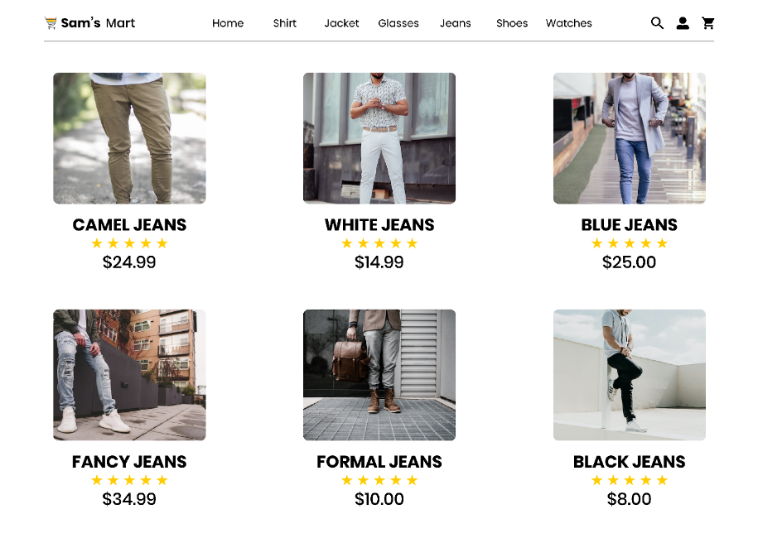

## Simplicity:

Our user interface is really simple as there is no vibrant colors are used. The interface has a very minimalist design which will attract the people more.

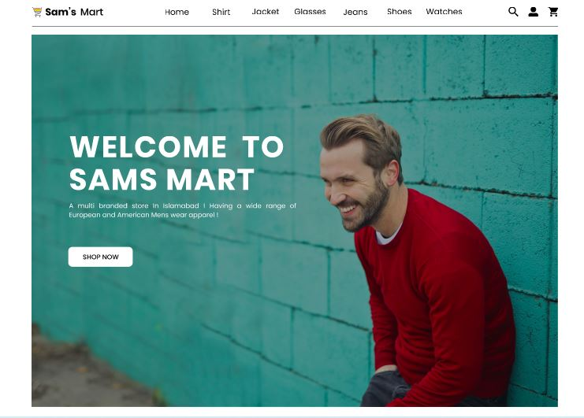

## Feedback:

The program meets the feedback user interface principle; in response to a user action, the system provides feedback, allowing the user to confirm that the action was carried out. As an example, in the menu, if the user points on any button it will perform a hovering effect and change its color.

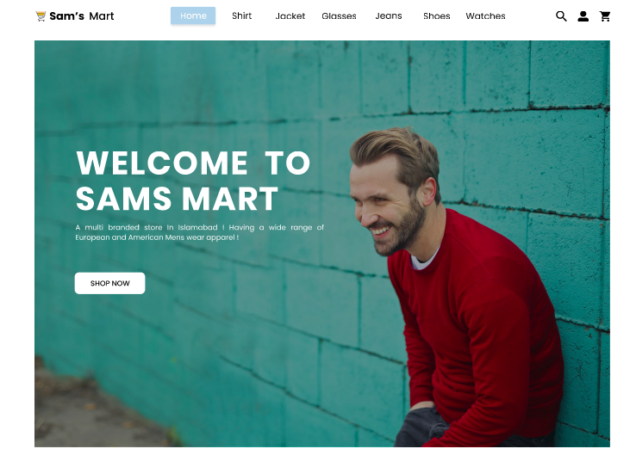

## Learnability:

The interface that we have designed is itself learnable every single entity is separately mentioned and there is no double meaning words or images which will make the user in doubt.

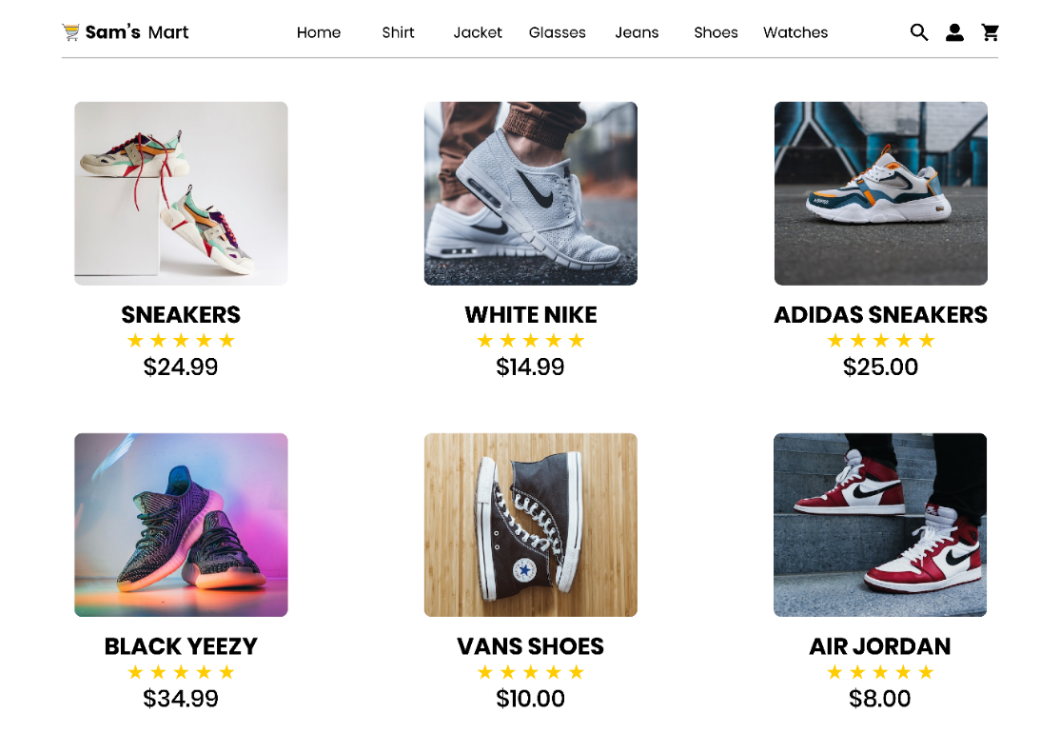

## Error Prevention:

Our interface has the ability for error tolerance, so if a user takes an incorrect action, the system will deliver an error message, prompting the user to take the appropriate action. In login, if user enter wrong username or password, then system shows error message that the particular information is invalid.

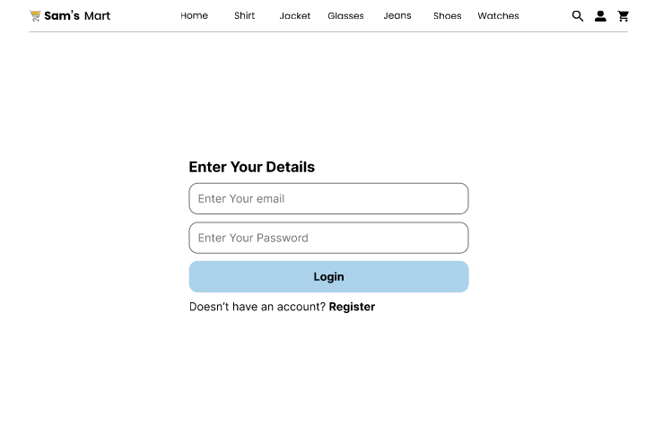

## User Control and Freedom:

The interface that we have designed is completely controllable by user there will be no interference of anything it will give user a freedom where user can explore interface itself.

# Design Screenshots:

Web View:

Landing Page:



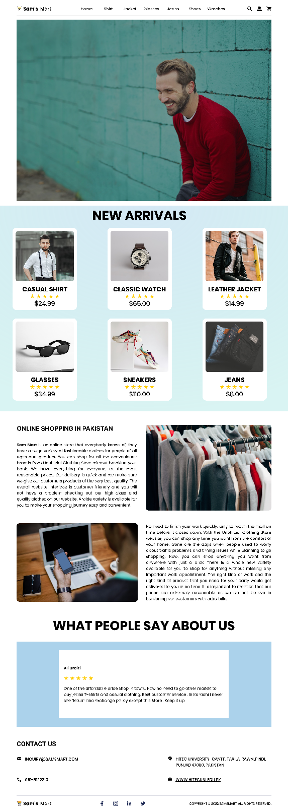

Shirts Page:

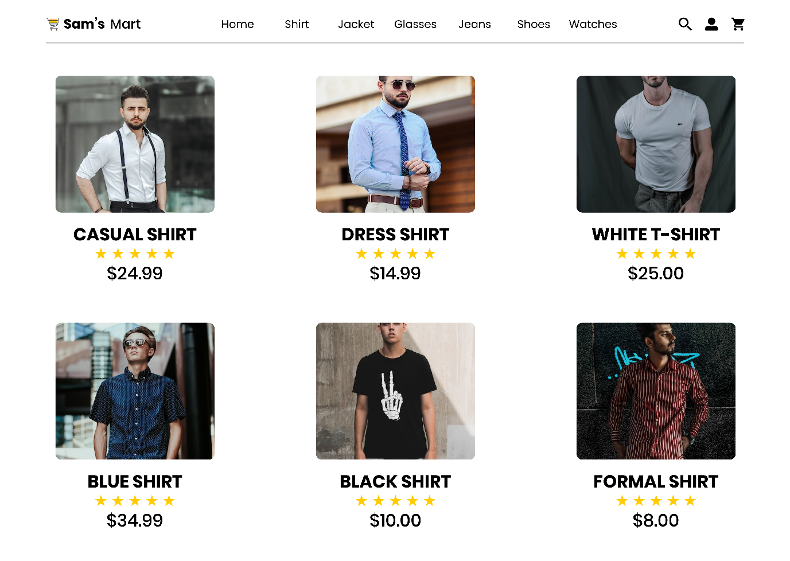

Jackets Page: 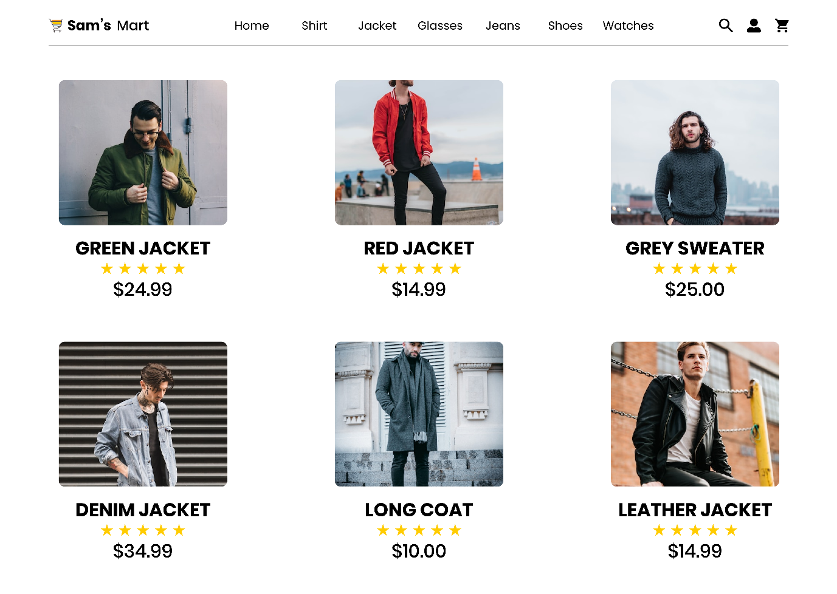

Jeans Page: 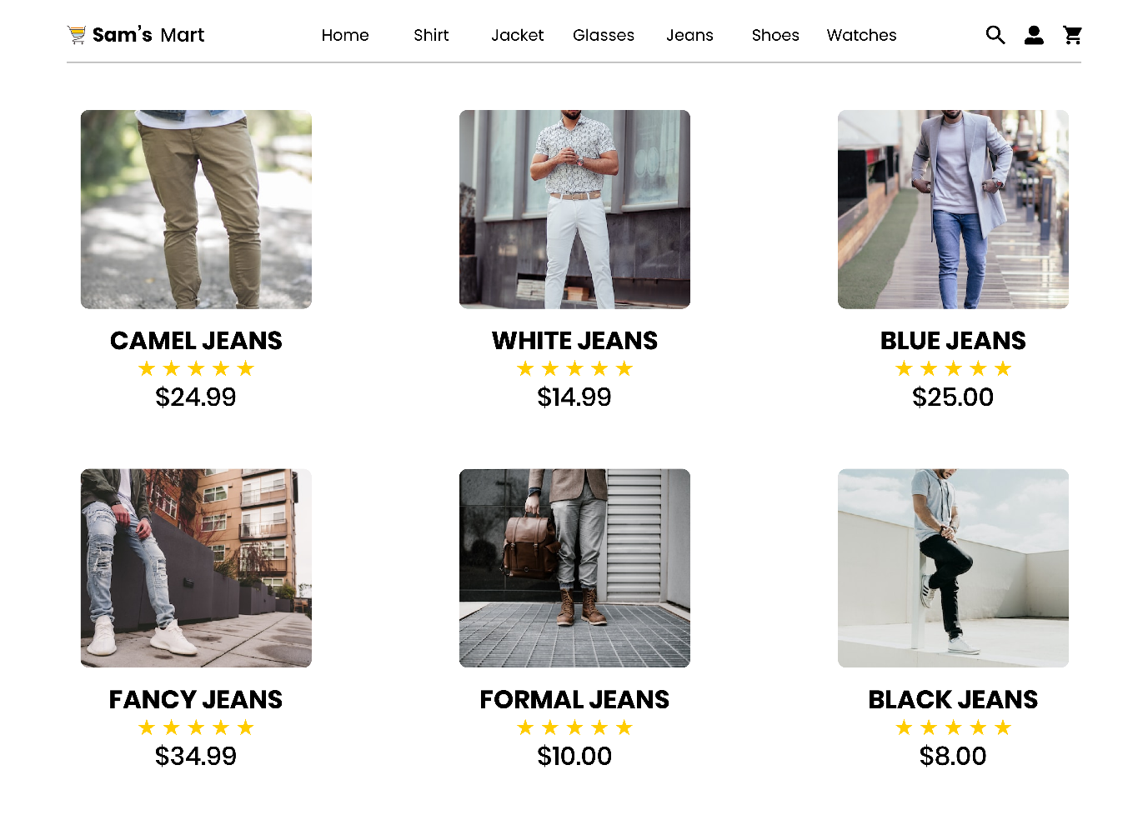

Glasses Page: 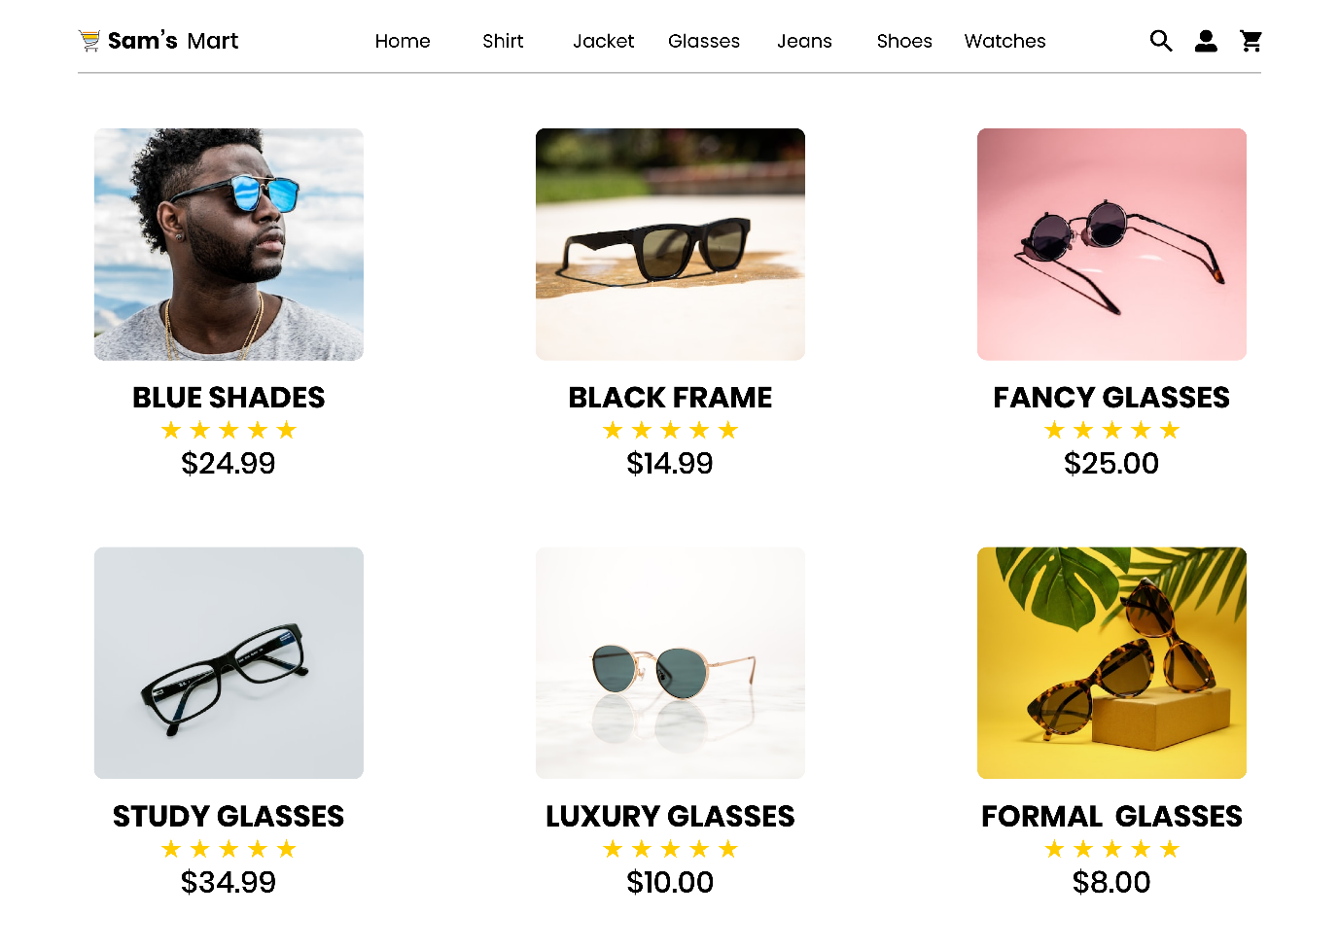 Shoes Page: 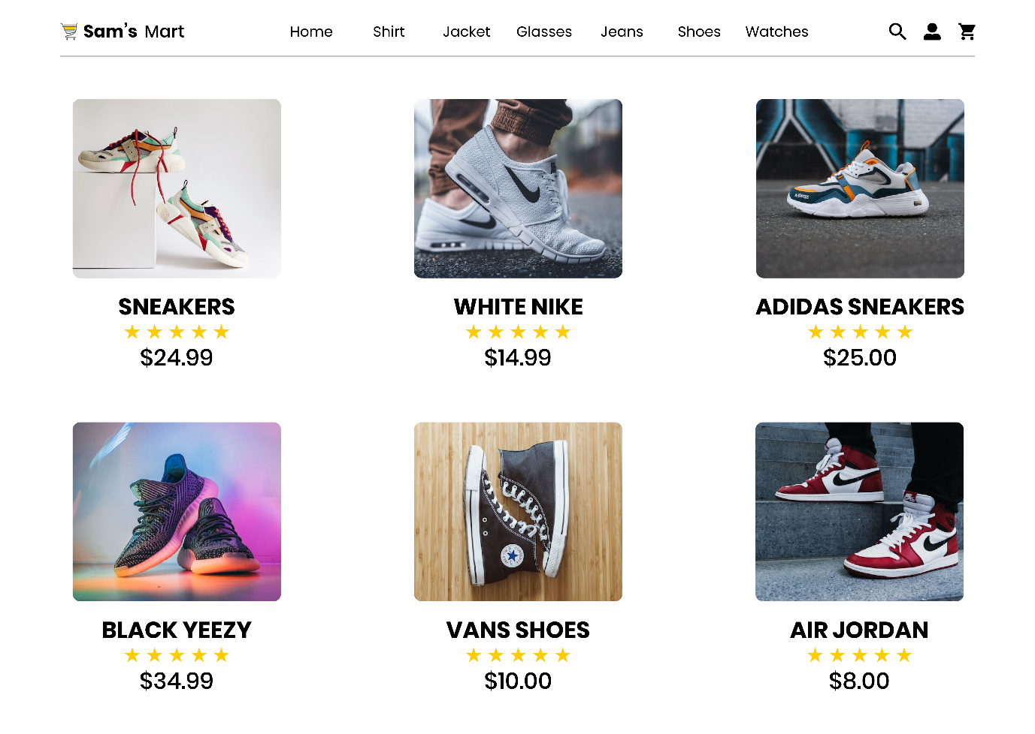

Watches Page: 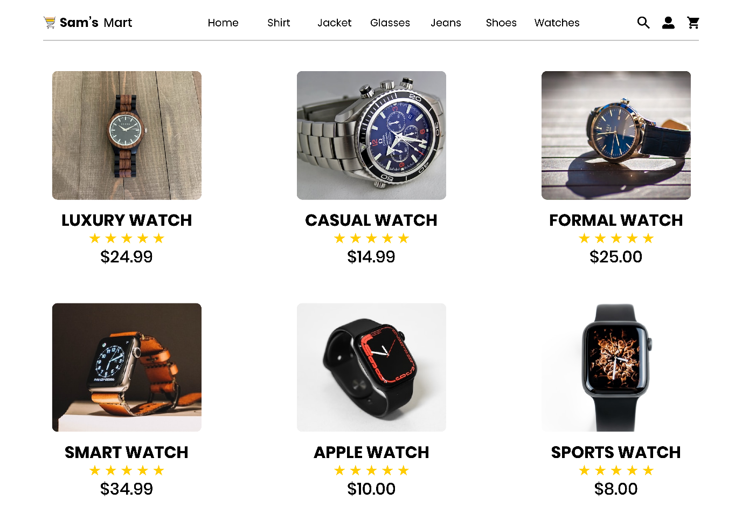 Cart Page: 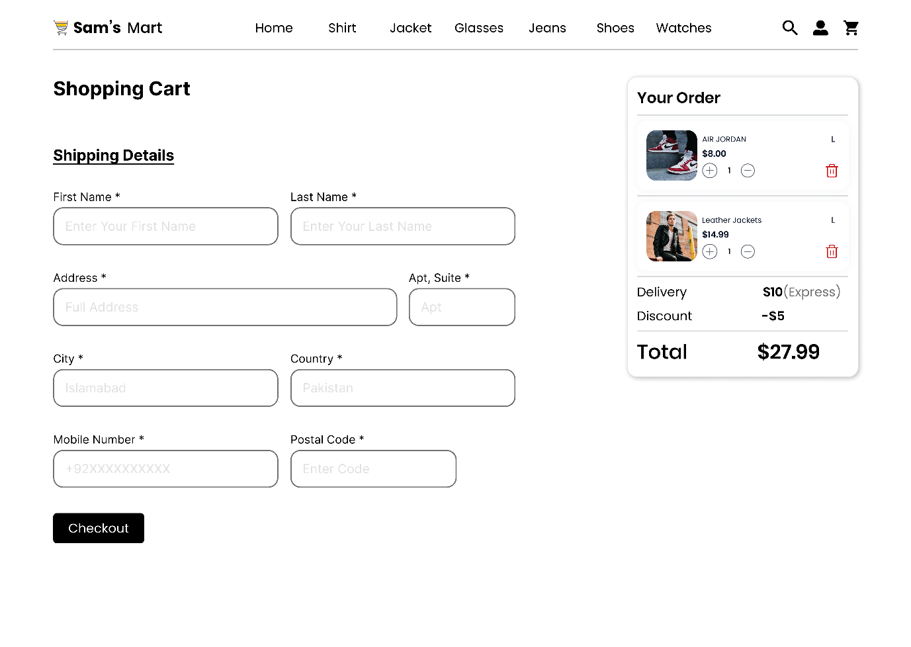

Checkout Page:

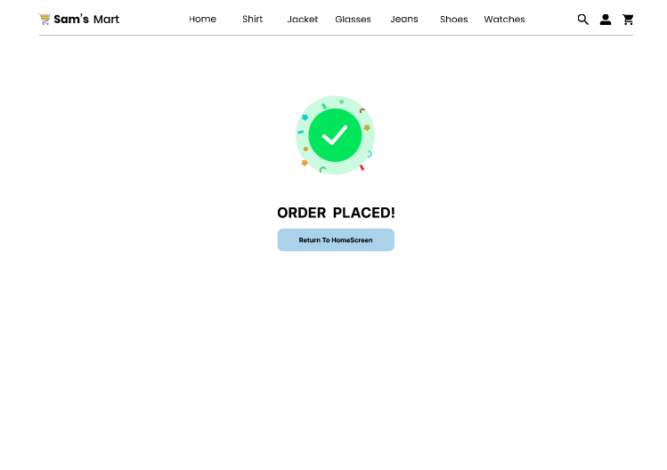

Login Page:



Register Page:

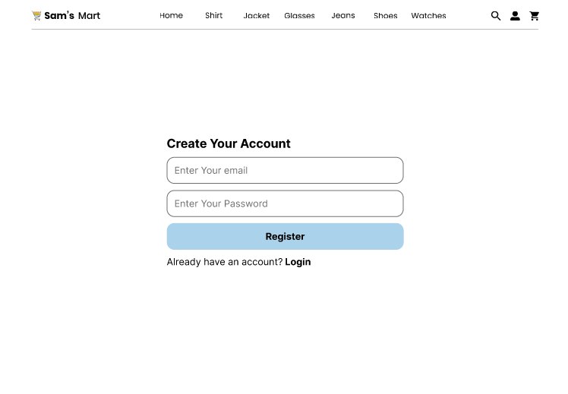

Android View:

Landing Page:

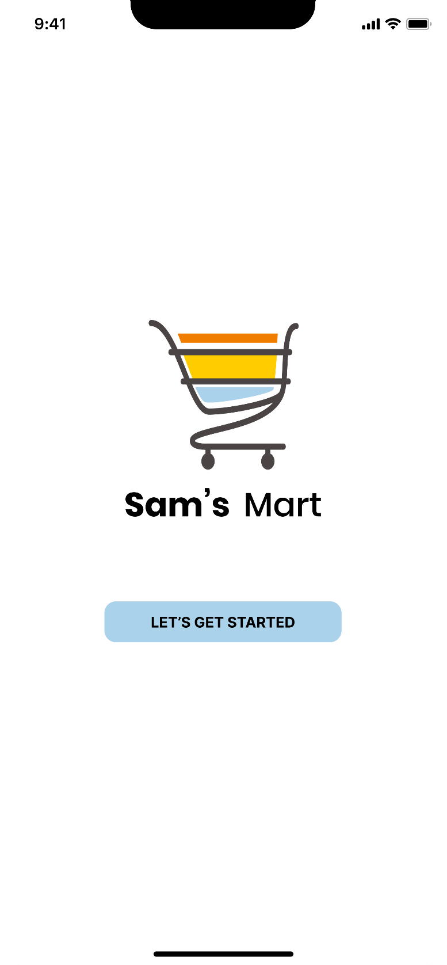

Home Page:

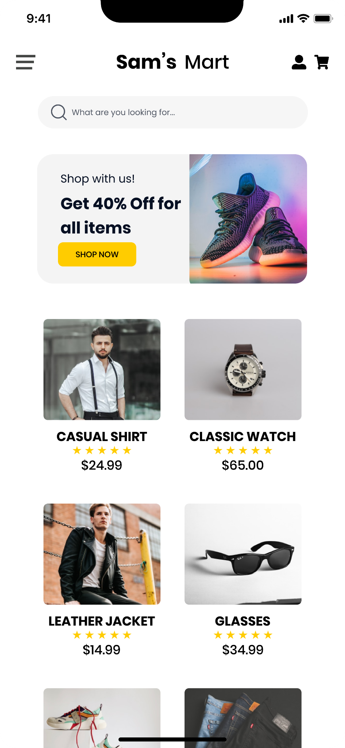

Slide Menu:

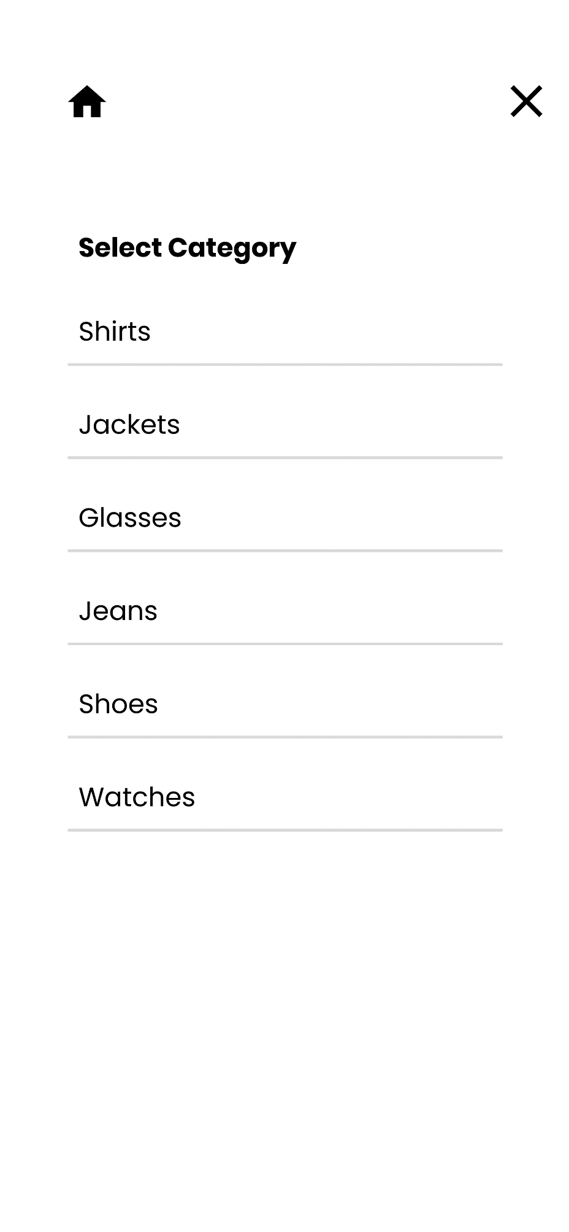

Landing Page:

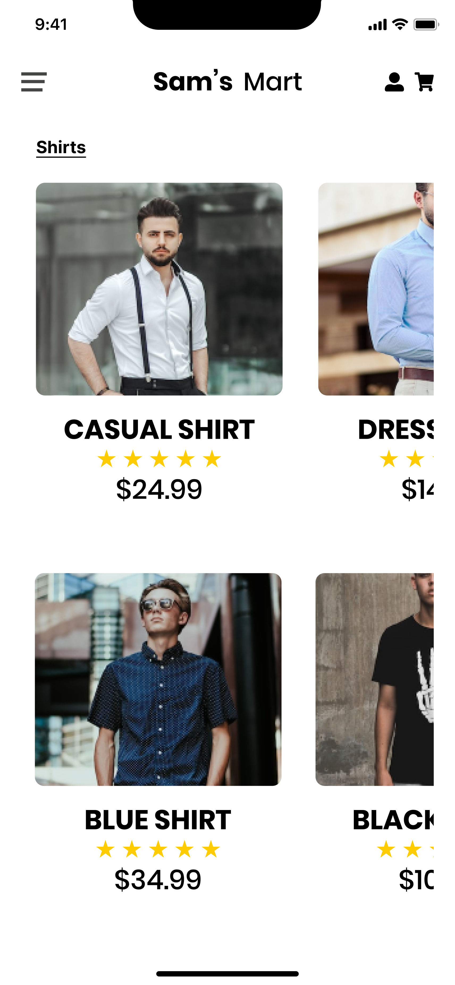

Jackets Page:

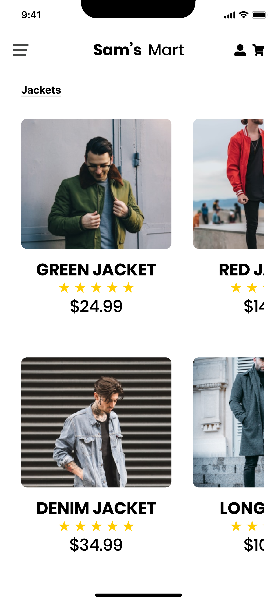

Glasses Page:

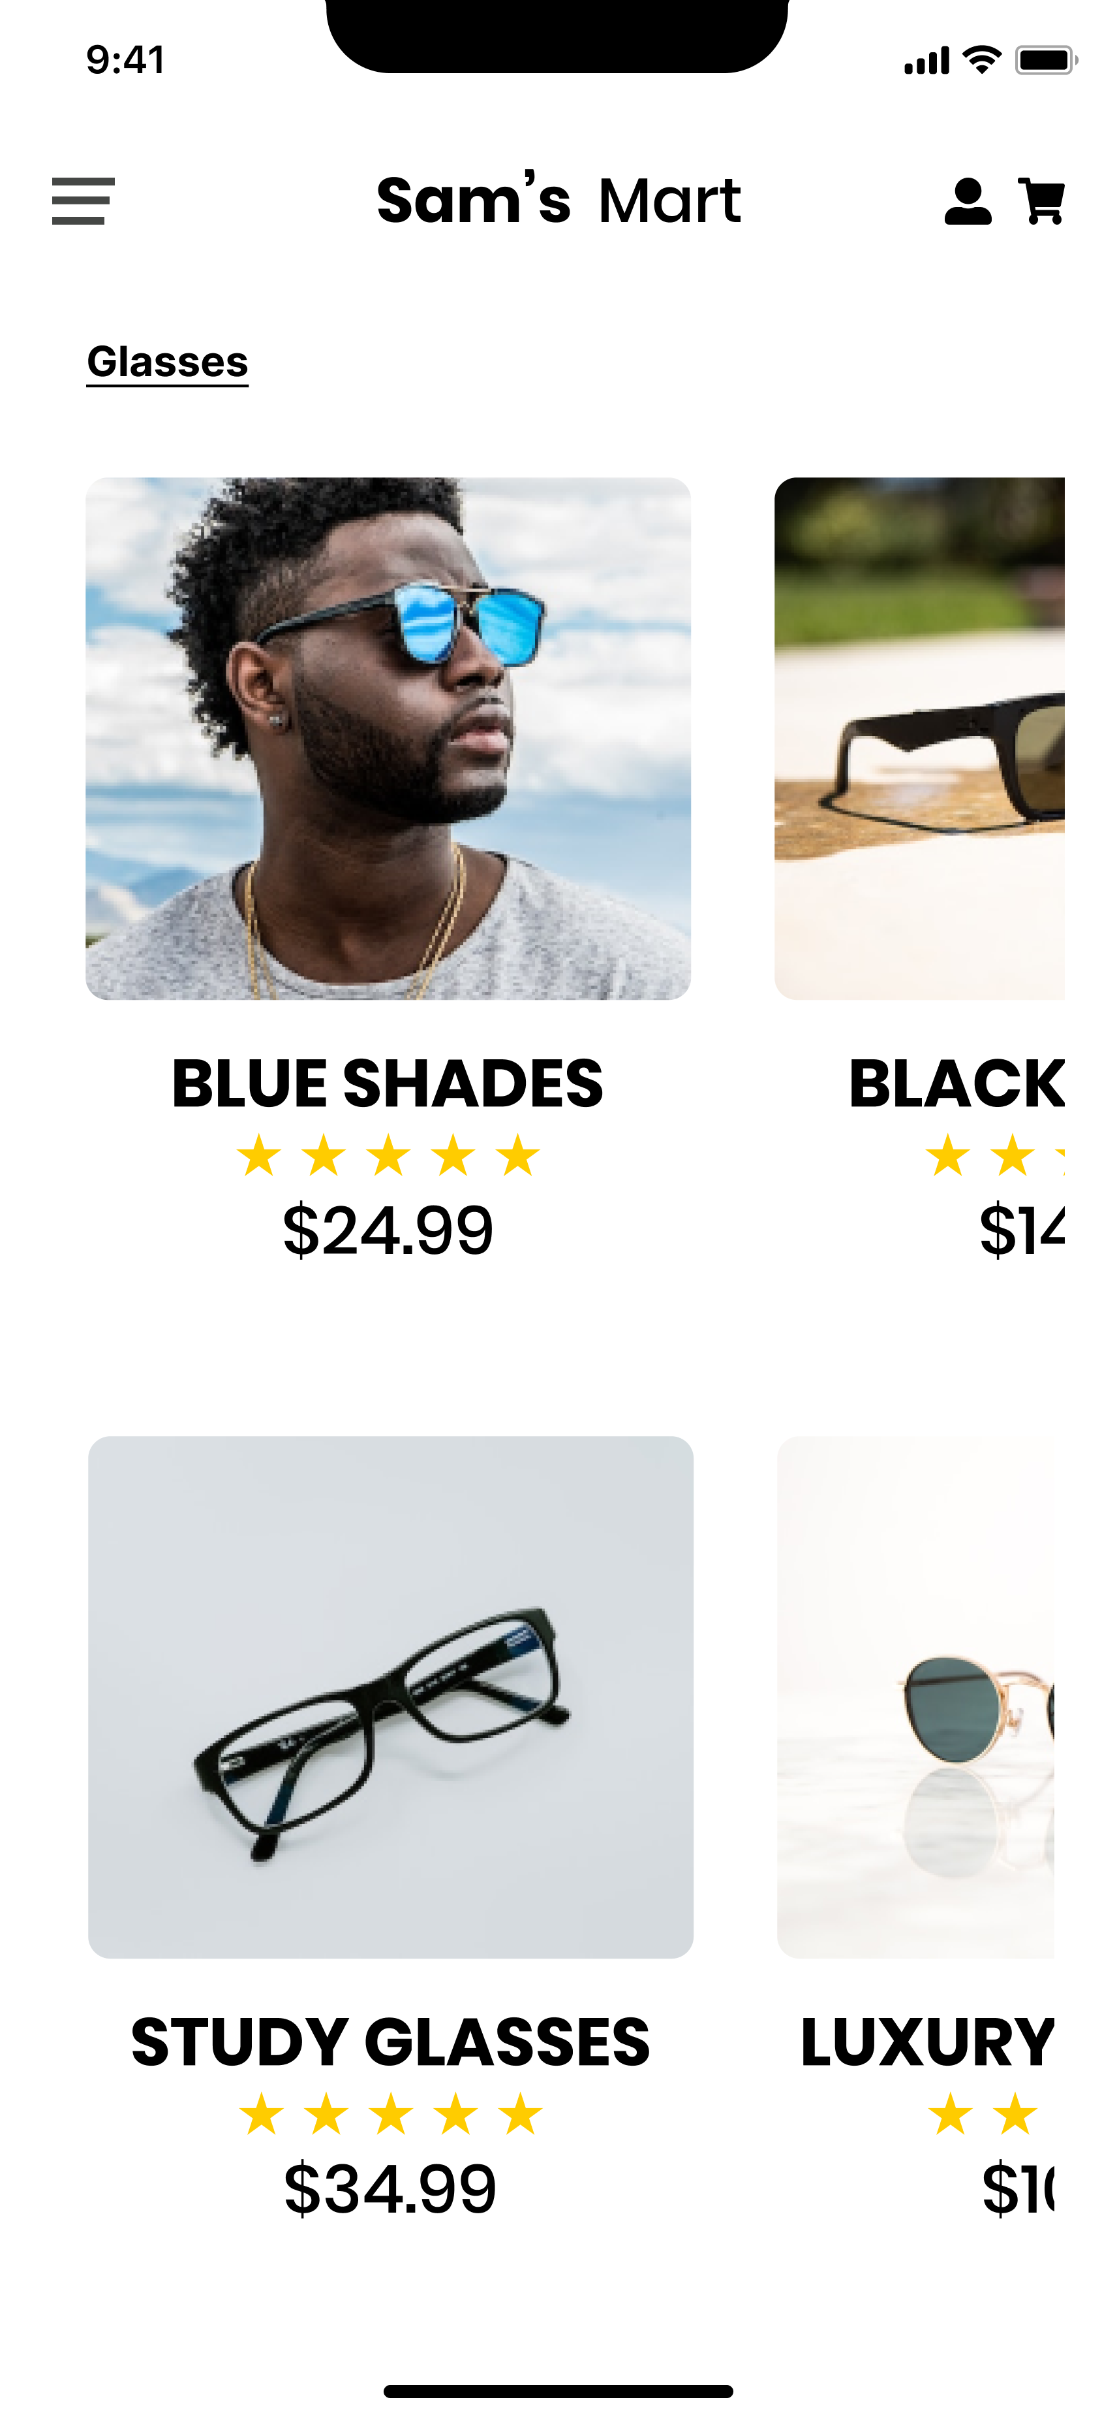

Jeans Page:

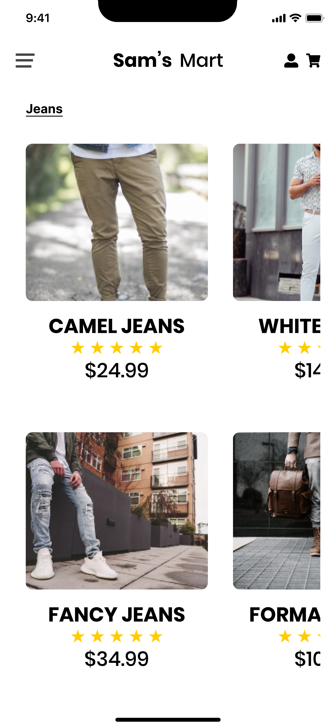

Shoes Page:

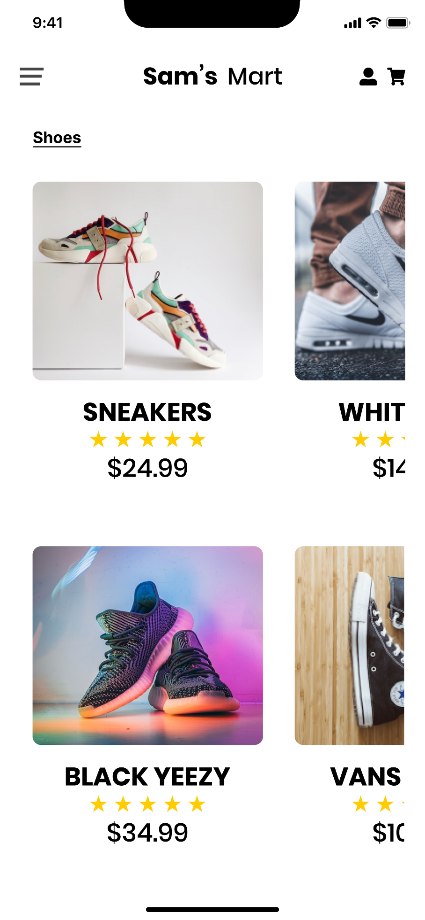

Watches Page:

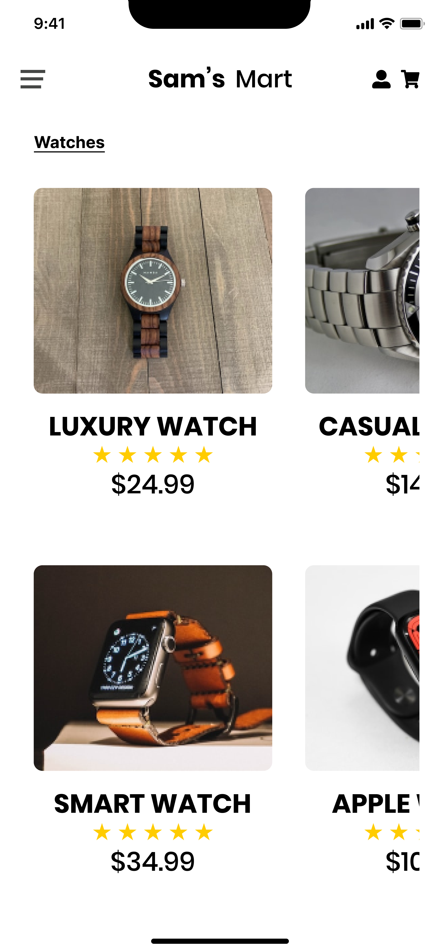

Cart Page:

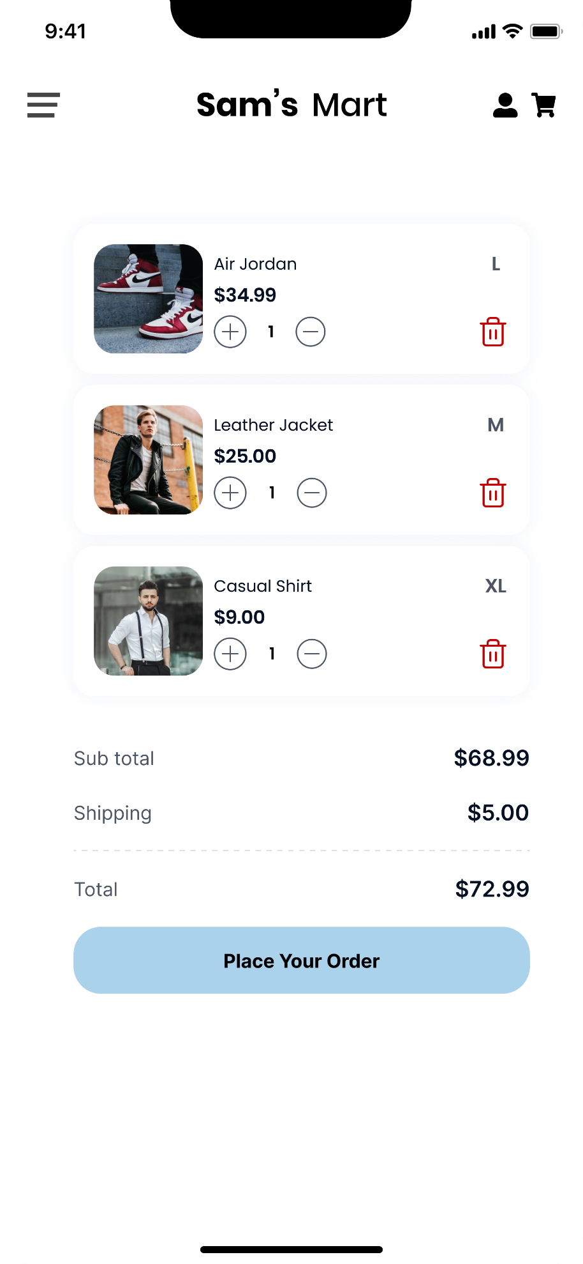

Details Page:

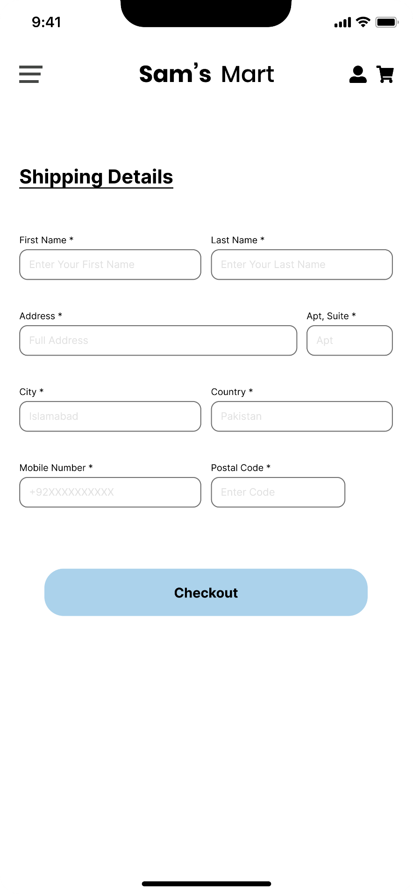

Checkout Page:

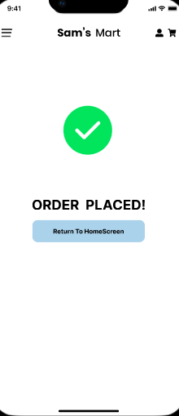

Login Page:

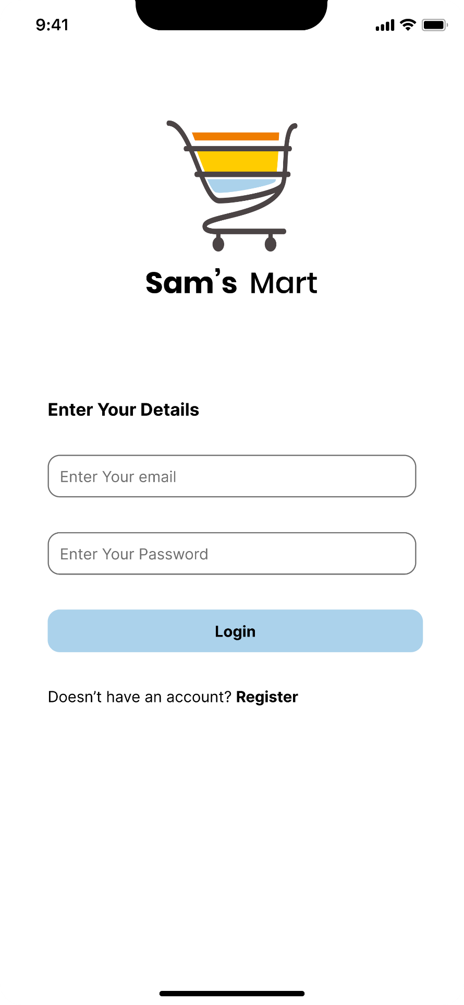

Register Page:

